IRF Quality Benchmarking
Screening Inpatient Rehab Facilities for Referral Networks

Part 2 of Project from SQL pipeline to Excel dashboard: ranking facilities on CMS quality measures, with a suppression audit that shows why a single composite score can mislead.

Business Problem :

A national post-acute care network is deciding which IRFs to include in its preferred referral network. Leadership wants a defensible way to rank facilities on quality — but CMS publishes quality across four measures (pressure ulcers, falls with major injury, discharge-to-community, and readmissions) on different scales, and many facilities are suppressed on some measures. Can we build a transparent, auditable composite score that ranks facilities, while being honest about how much suppression undermines the ranking?

Click here for the Excel Link
Click here for the GitHubLink

Core Questions:
- Which facilities are top performers, and can we trust the ranking?
- Is quality measure-specific or general?
- How many rehab facilities are safe to steer referrals to, and how much does CMS data suppression limit the answer?

Method: (Part1) PostgreSQL pipeline (raw CMS → facility scorecard → state/region views → composite index) →(Part 2) Excel dashboard with leaderboard, suppre ssion audit, geographic view, and measure-independence analysis. Next Steps→ (Part 3 - 4)Power BI then Python.

Tools Used:
- Excel Online — full dashboard build: pivots, slicers, KPI tiles, charts, conditional formatting
- Pivot Tables — aggregated ~900 IRF facilities by benchmark status, composite score, measure verdicts, and state
- Pivot Charts — clustered bar charts for % Better vs % Worse per measure; suppression impact chart
- Calculated Fields — derived % Worse (judged) and Better_Count inside pivots without adding source columns
- Slicers — interactive state / region / benchmark-status filters for drill-down
- Data Modeling — joined three tables (irf_composite_index, irf_facility_scorecard, measure_reference) on ccn and measure_code
- Excel Analytics Functions — LET, FILTER, SORTBY, TAKE, HSTACK, COUNTIFS, AVERAGEIFS, IFERROR, XLOOKUP
- Data Cleaning — handled NULL text, "Not Available" verdicts, text-stored numbers, and CMS suppression flags
- Statistical Analysis — % Better vs % Worse, suppression rate, equal-weighted and trimmed averages, top-decile state hotspots
- Dashboard Design — compact KPI cards, Top-10 tables, trust tiles sized for single-screen layout
- Business Framing — translated CMS quality measures into a referral-safety decision framework (Safe / Caution / Cannot judge)

Steps
I uploaded the CMS data tables created in Postgres using SQL queries into Excel with each table created from the SQL project: Hospital Rehab Analysis from part 1 into Excel. Then took the table data and made each into labeled tables. Thought up of the next core business problem first using the table data that i created, and came up with the core questions listed above to center relating to the main business problem; healthcare networks needs a transparent, auditable composite score to rank providers despite mixed-scale measures, data suppression, and unclear quality dimensionality. I then drew up a wireframe prototype using the core related problem as the main driving vision I needed for the dashboard so users at a glance can view the necessary related data.

Wireframe Prototype of Excel Dashboard 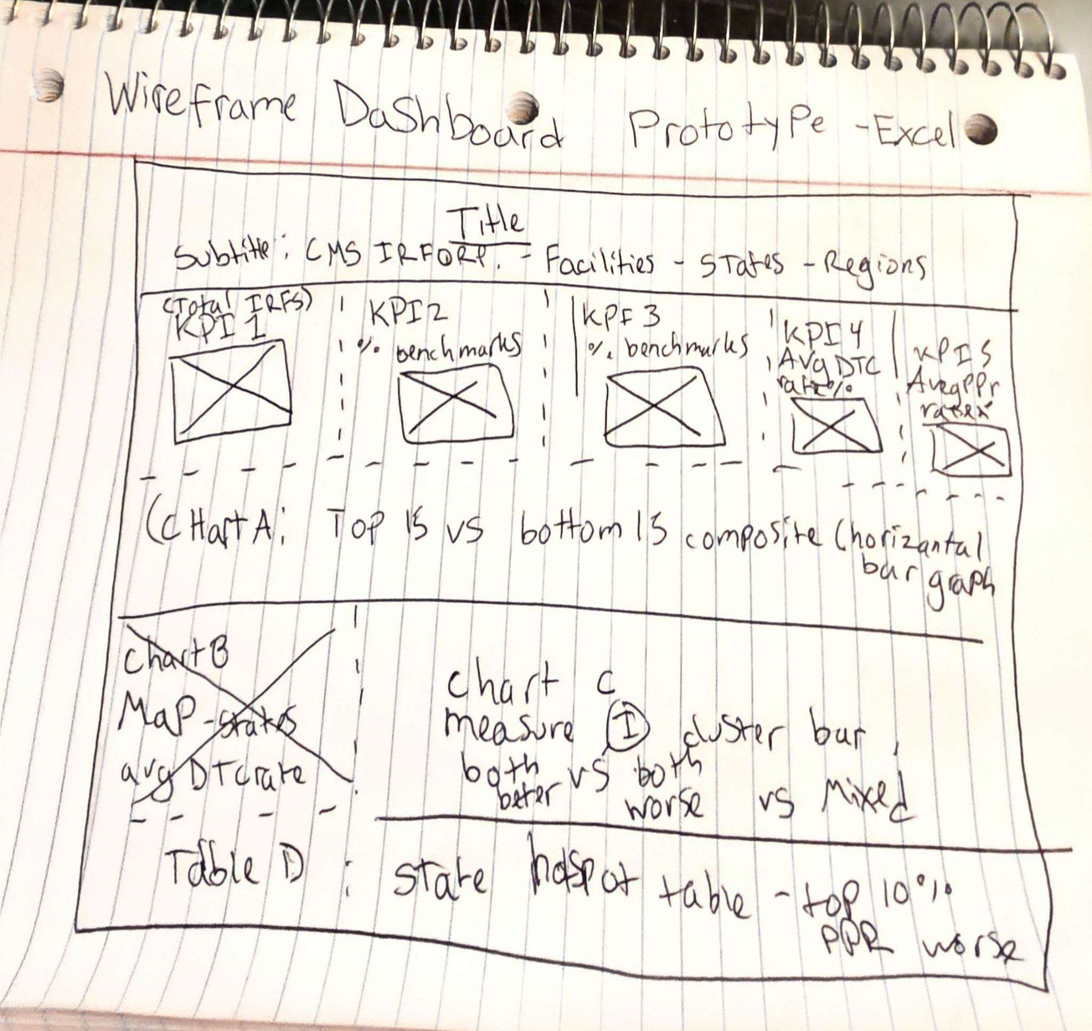

Answering the core Question: Which facilities are top performers, and can we trust the ranking? I proceeded to create a Pivot table from the IRF Composite Index Table using the values to indicate Benchmarks for the top performers and the ranking as well. Making the Pivot table with the following information dragged in with state and provider_name nested as the rows, the values as composite_score maximum, measures_evaluable maximum and finally the filter as benchmark_status. This information will be able to display a pivot table using the data to answer the core question and show the top performing facilities using benchmark measure score and composite scores, with the necessary data displaying the results. 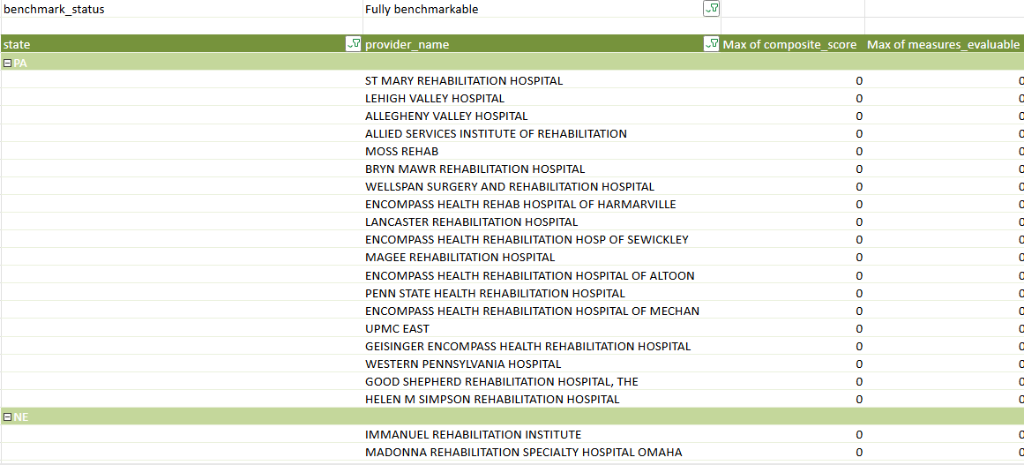

I proceeded to copy the pivot table I made prior and pasted it right next to it to display bottom performers then proceeded to filter the data to display the descending min values of the composite score to show in each state the Bottom 15 facilities with the worst scores. 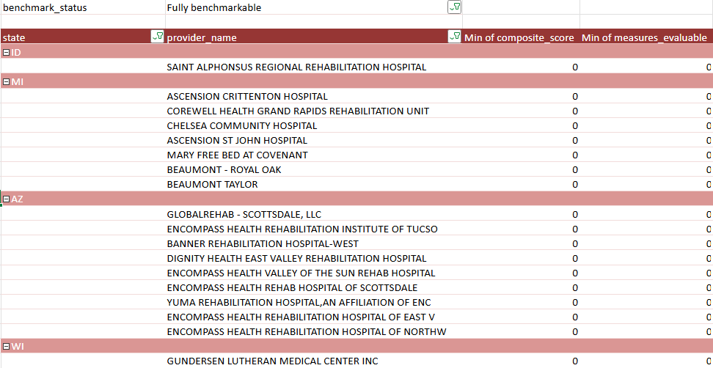
I Proceeded to create another pivot table to measure the fully benchmarkable status and scores of the facilities and partially suppressed percent as a KPI index tool to display the % of the status for inserting the information into my final dashboard. I corrected the tables into one table to showcase the top performing facilities with a score benchmark of 2 or higher and sorted the values into one table to give a closer look at the table and display proper information regarding top benchmark score stats of the top 20 facilities with high benchmark scores of 2 or higher. 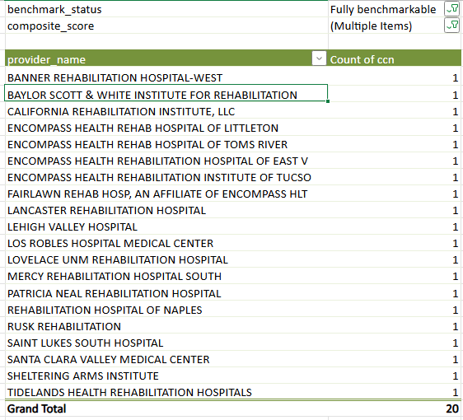 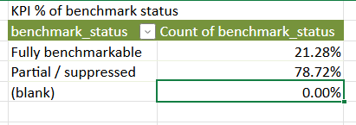
Copied the Pivot table created prior and pasted right next to it to create new KPI data pivot table and updated the count of benchmark_status to displaying the count instead of %.
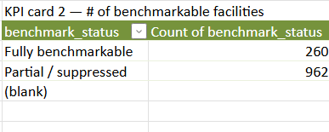
To make the next KPI information I gathered the MAX to the MIN table scores from composite_scores from the irf_composite_index table sheet. Using the following code to produce the necessary score range min to max. Later I added this information to my final dashboard into a KPI visual Card for users to view.
=LET(
vals, VALUE(Table1[composite_score]),
nums, FILTER(vals, ISNUMBER(vals)),
MIN(nums) & " to " & MAX(nums)
)

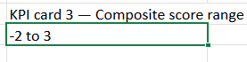
I addressed the following core question next up in my project: Is quality measure-specific or general? Thinking critically to gather information necessary for addressing this core business question is necessary, my thought process on this is to be able to view data in specific a curated table to identify the % of each table to showcase measurable for co- performances via best, worst data percentages. Below is the Table results of the percent from better and worse outcomes of each measure index.

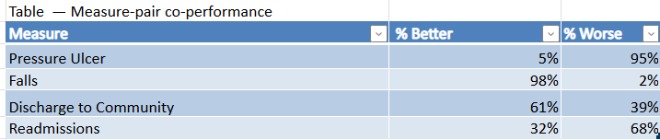I wrote calculations in order to get the % results in the % columns of the following: =COUNTIF(Table2[pressure_ulcer_vs_benchmark],"Better than the National Benchmark")
/ (COUNTIF(Table2[pressure_ulcer_vs_benchmark],"Better than the National Benchmark")
+ COUNTIF(Table2[pressure_ulcer_vs_benchmark],"Worse than the National Benchmark"))
Changes the different benchmark labels and also switching the worse vs better tailoring each for its appropriate values from the Table2 - of irf_facility_scorecard in order to get the final % outcome, i also changed the results to display % instead of a floating number and decreased the decimal to display full % amount.

Proceeded to create the value in order for the next KPI card indicator data metric that i wanted in my final results dashboard, the average discharge rate % of facilities. In order to get this information i needed the average % of the dtc_rs_rate_pct i created in the SQL table from my previous project from the irf_facility_scorecard table. I ran into some minor issues of a division by zero error. (Error visual result from - >)=AVERAGE(Table2[dtc_rs_rate_pct]).
I began to break down the steps in order to view if the table results are null/void or if it was a different data type such as text instead of an actual #. I wrote the following code: =COUNTA(Table2[dtc_rs_rate_pct]) to view if there are any void/null errors or if data is void, results displaying a count of 1222 showing that the table metrics are there and the data is not null/void. I then proceeded to do a regular Count to view if results gave a 0 to show that its numerical or text based. =COUNT(Table2[dtc_rs_rate_pct]) resulting in a 0 in which my hypothesis was correct. In order to problem solve this i used critical thinking of how can i proceed to transform this data into actual numerical values with the following code.=LET(
r, VALUE(Table2[dtc_rs_rate_pct]),
AVERAGE(FILTER(r, ISNUMBER(r)))... Finally resulting in numerical value results that i wanted, i began to correct the data from 67.22599823 to a viable percentage whole number to clean it up and get that numerical % value i wanted to showcase by transforming it into a % and lowering decimal places by two and also dividing the number in the Let function by 100. I created it into a table resulting in the following:

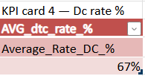I now need for the last KPI card number 5 the same metrics for the average ppr rate %, i utilized the same formula and transformation to display the following table changing the column details the code is selecting from the table irf_facility_scorecard. Resulting in the following table after cleanup and data transformation: 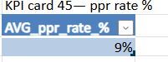
Focusing on answering the final core question: How many inpatient rehab facilities are safe to steer referrals to, and how much does CMS data suppression limit the answer? I need to be able to view the region CMS data suppression. I need to know how many facilities are fully benchmarkable by benchmark status from the irf_composite_index continuing that data.
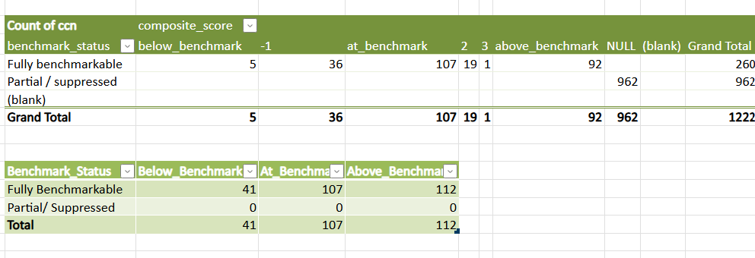I created a pivot table holding all the data and metric count of the full benchmarkable vs partial benchmark facilities. The top table contains all the data and the bottom contains the grouped column of below benchmark ranging -2:-1, at benchmark is 0, and above the benchmark ranging 1-3+. I now need to create a pivot table to showcase the top 10% state hotspots for the PPR worse outcome to add a chart on bottom right of the dashboard displaying this information. I need the potentially preventable readmissions (PPR) worse than the national rate at the highest concentration. "Top 10%" = the states in the worst decile of % of facilities rated Worse on PPR. Taking a look at the table irf_facility_scorecard it has the information needed for this table; ppr_vs_benchmark and the state column. I proceeded to create a pivot table from the information listed. I also want to showcase the % amount of the better than national rate in those states that have the top worse % of PPR rates. 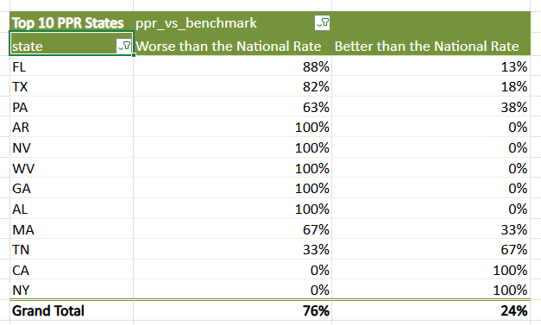
This Table showcases the top 10 worst % rate of states with the highest % of the worst PPR and also the % of the better than national average as well to display the difference. Now I have all the data i need and answer all the main core questions. I created databases from the metrics and tables to pull the correlating information for the main business problem. For the fun part now to make the dashboard. I proceeded to make charts, bars, graphs and also KPI visual cards from the tables and information I pulled all above into visual sections to display onto my final dashboard. I added slicers to narrow down the results and filter by category. Below i have the final results of the dashboard. 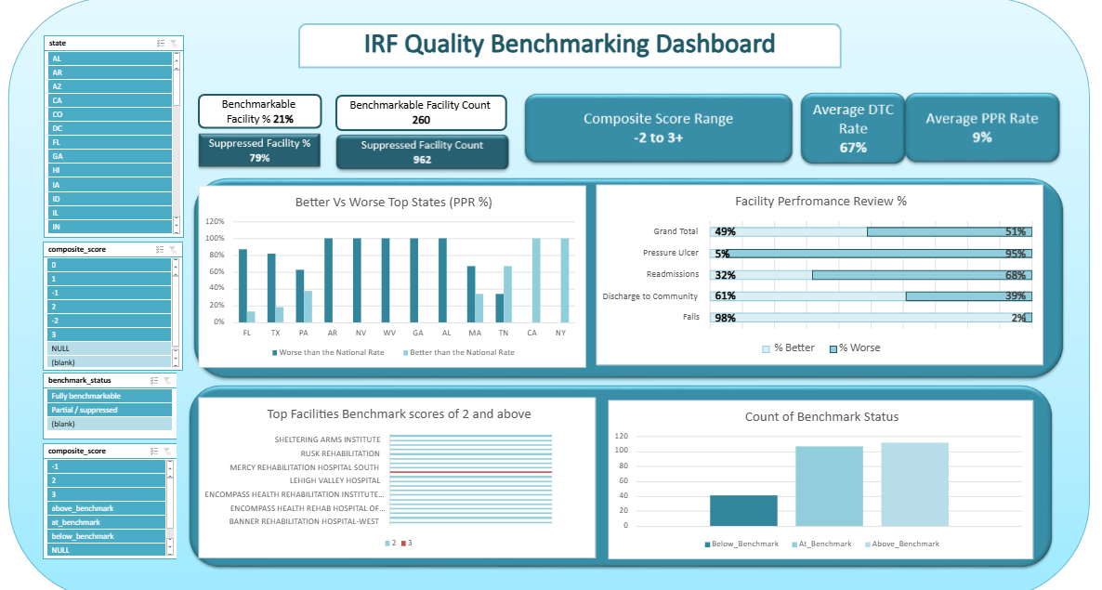

Key Findings
- Only facilities that are Fully benchmarkable and have no "Worse than national benchmark" verdict qualify as safe to steer referrals to
- Roughly 85–90% of IRFs are Partial / suppressed — CMS hides at least one measure, so they cannot be ranked or compared
- The referral-safety answer covers only a small, fully-measured minority of facilities
- Rankings were restricted to benchmark_status = Fully benchmarkable and measures_evaluable = 4, so every ranked facility was scored on all four measures
- The dashboard makes the suppression limitation explicit rather than hidden, so decision-makers see both the recommendation and its confidence level

Conclusion Summary
This project set out to answer a practical healthcare question: which inpatient rehabilitation facilities are safe to steer referrals to, and how much does CMS data suppression limit that answer? By integrating three CMS datasets into a single Excel dashboard, the analysis produced two clear findings. First, only a small minority of facilities qualify as genuinely safe to steer to — those that are fully benchmarkable and carry no "worse than national benchmark" verdict on any of the four quality measures. Second, CMS suppression is the dominant constraint: roughly 85–90% of IRFs have at least one measure hidden, meaning they cannot be ranked or compared from public data at all. The dashboard addresses this honestly rather than hiding it — rankings are restricted to facilities scored on all four measures, and the suppression rate is presented as a first-class KPI so decision-makers see both the recommendation and its confidence level. The result is a defensible, transparent analytical tool that answers the referral question while making the limits of the underlying data impossible to overlook. The project is now being extended into Power BI for interactive reporting and Python for automated pipelines and suppression-bias analysis — demonstrating the full analyst workflow from raw CMS data to dashboard to predictive modeling.

